

**Report of Mini Project**

Data Structures, CSE-207; Sec 3, Group no 3

**Group Member 1:**

Name: Md. Ariful Islam Anik

ID: 2021-1-60-028

**Group Member 2:**

Name: Md. Farhan Tonoy

Id: 2021-1-60-126

**Submitted to:**

Prof. Dr. Md. Rezaul Karim

(DEPT. of Computer Science And Engineering)

**Introduction**

A priority queue is a special type of queue in which elements are associated with a priority value and elements are served on the basis of their priority. Higher priority elements served first.

The main object of this mini project is to design a priority queue which can handle specific operations with menu bar. We implemented Insert, Delete, print, Change priority and exit operations in this project. We have used all the trending technologies in market with maximum functionalities, efficiency to solve the project.

**Block Diagram Features**

There are multiple features in this mini project according to the instruction. These are:

1. **Insert**: Four option in insert.
2. Unique Id
3. Sender Name
4. Priority
5. File size (Calculated Automatically)
6. **Delete**: Simply Delete the first priority Data.
7. **Display**: Display All the data in the file
8. **Change priority**: Priority of the file can be modified.
9. **Exit**: Simply Exit from the program.

Each time Each attempt and operation is saved to a file in the system and information can be found later from reading the file. Each data can also be updated and modified too.

**Flow Chart:**

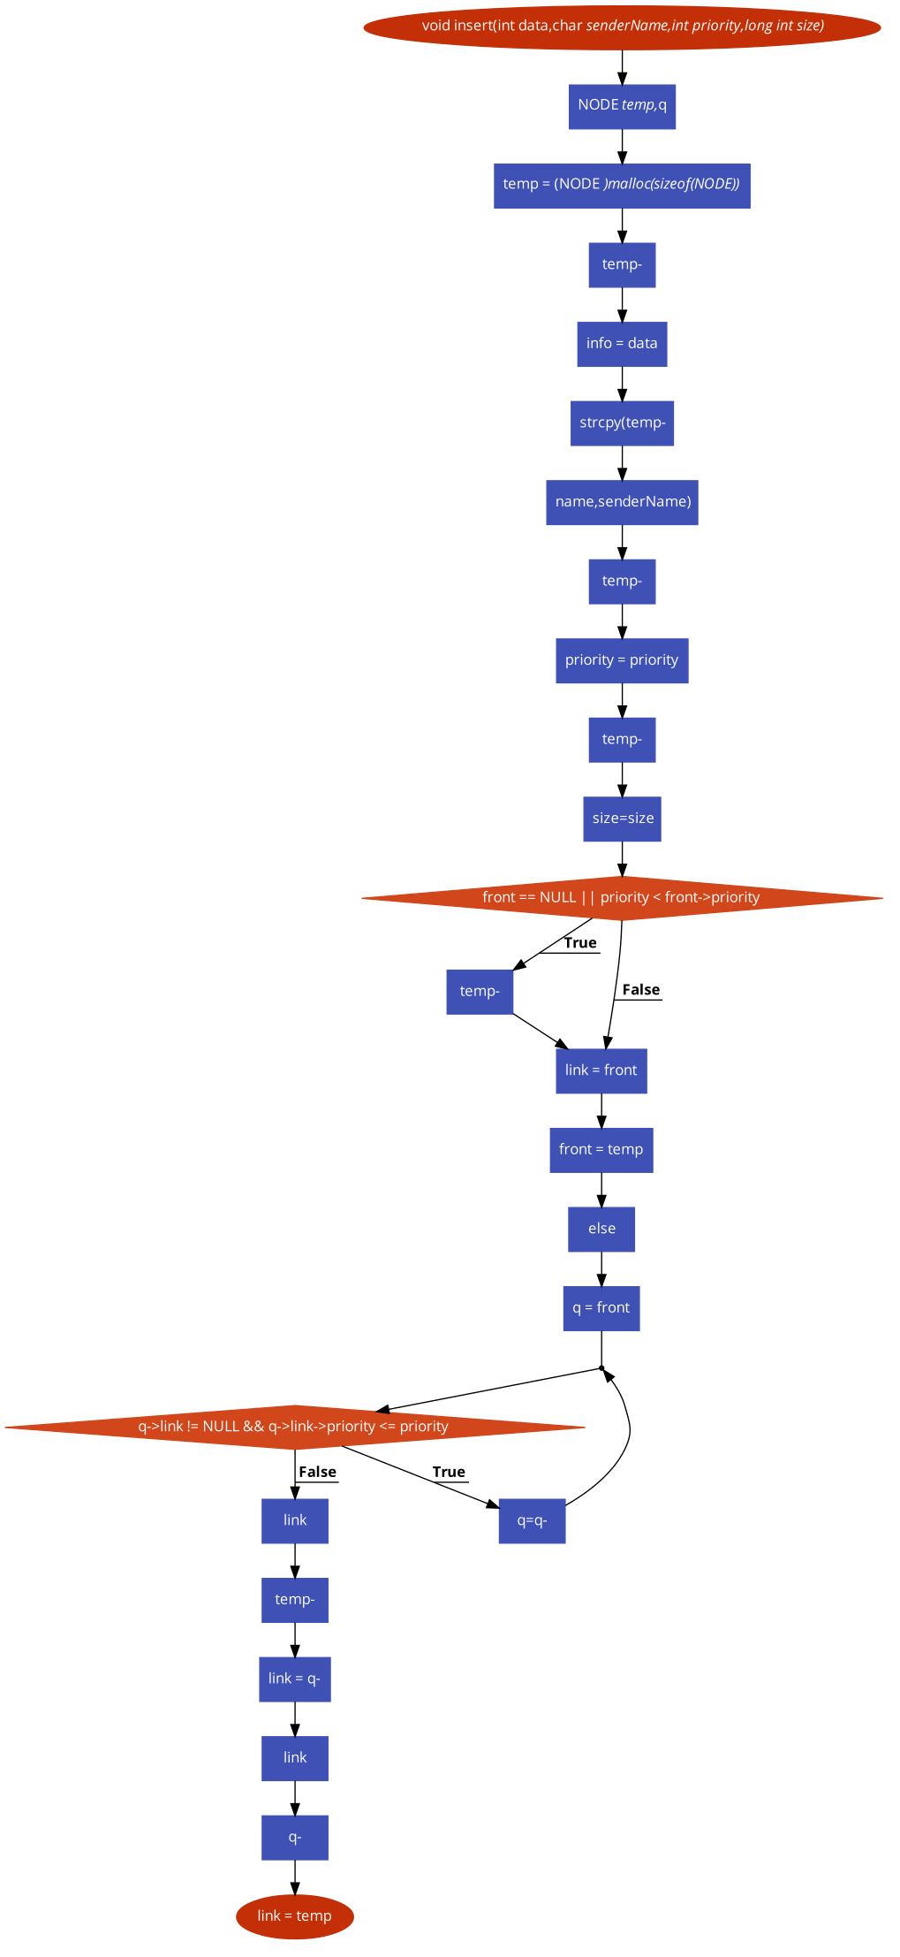**For Inserting**

**For Deleting**

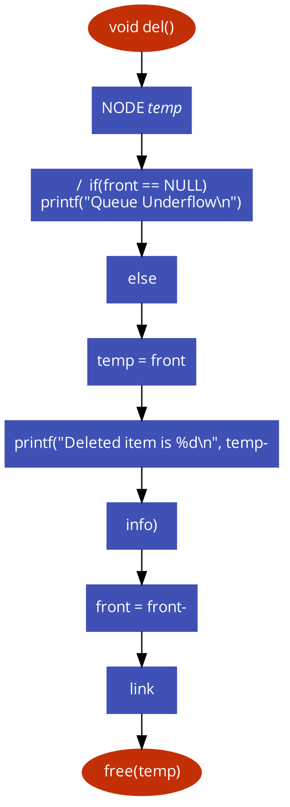

**For Updating**

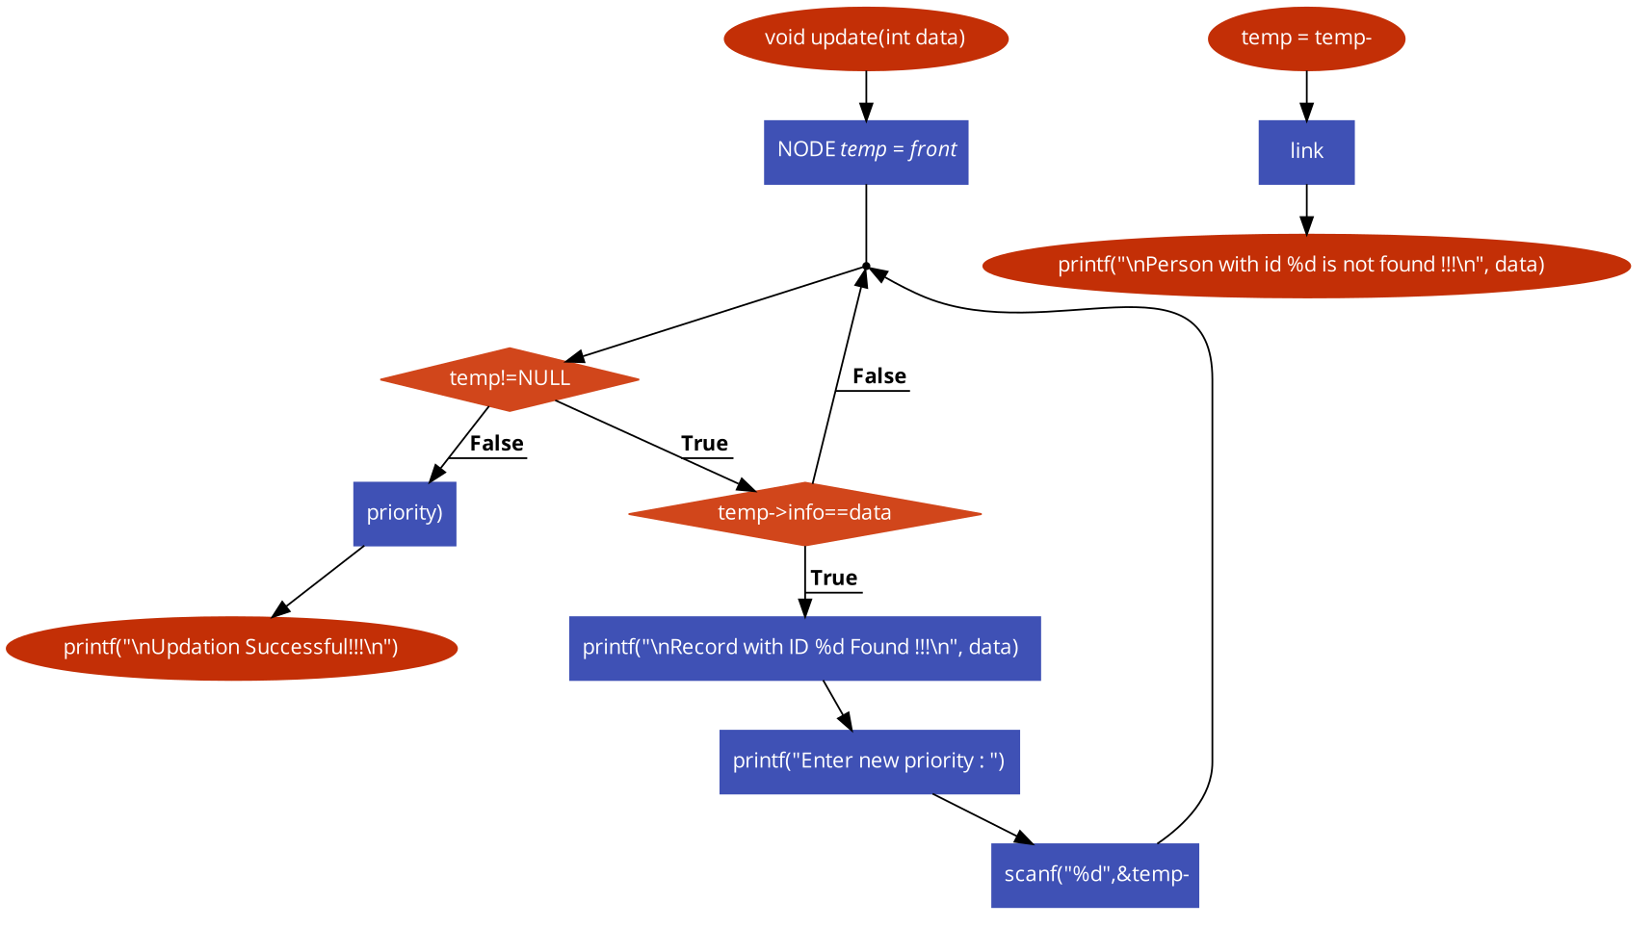

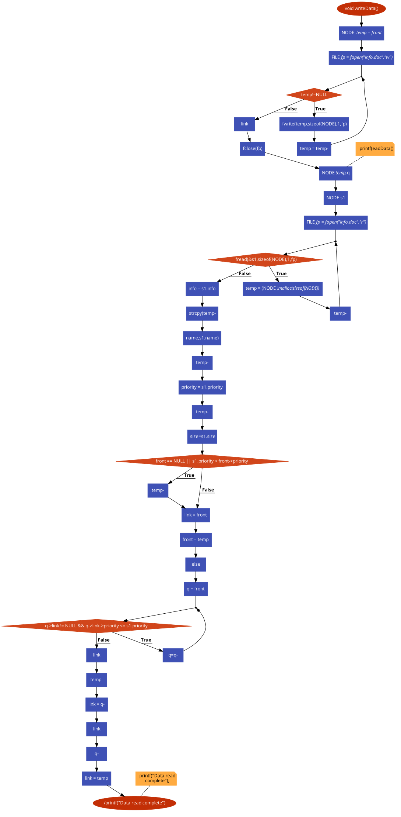**For Reading & Writing**

**For Finding size**

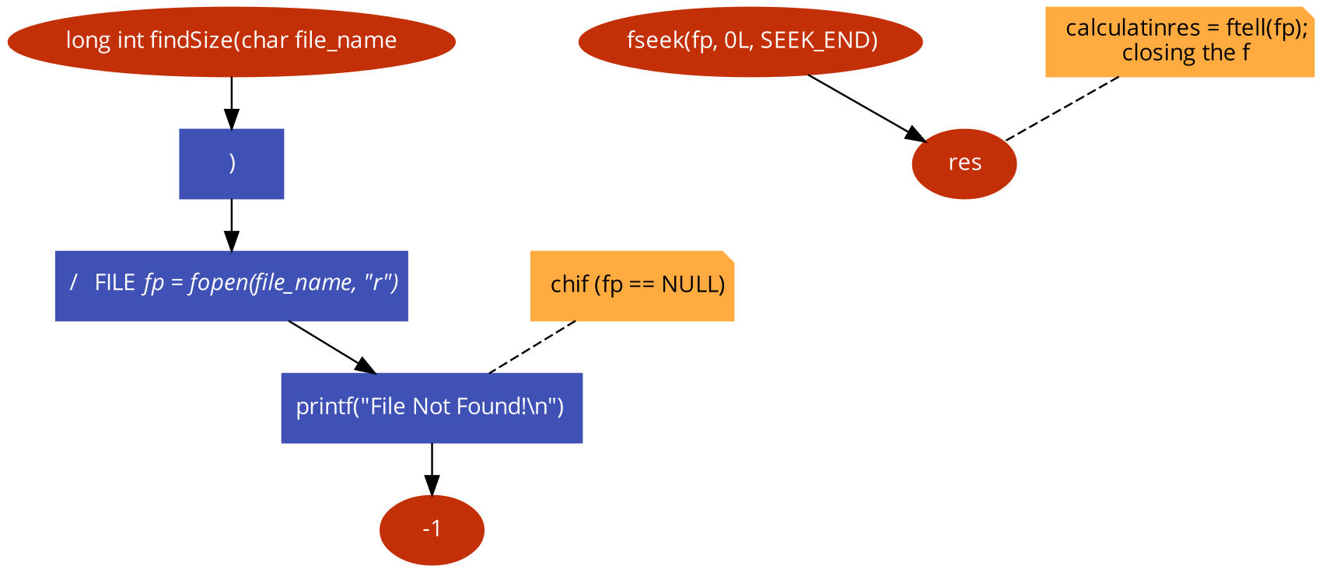

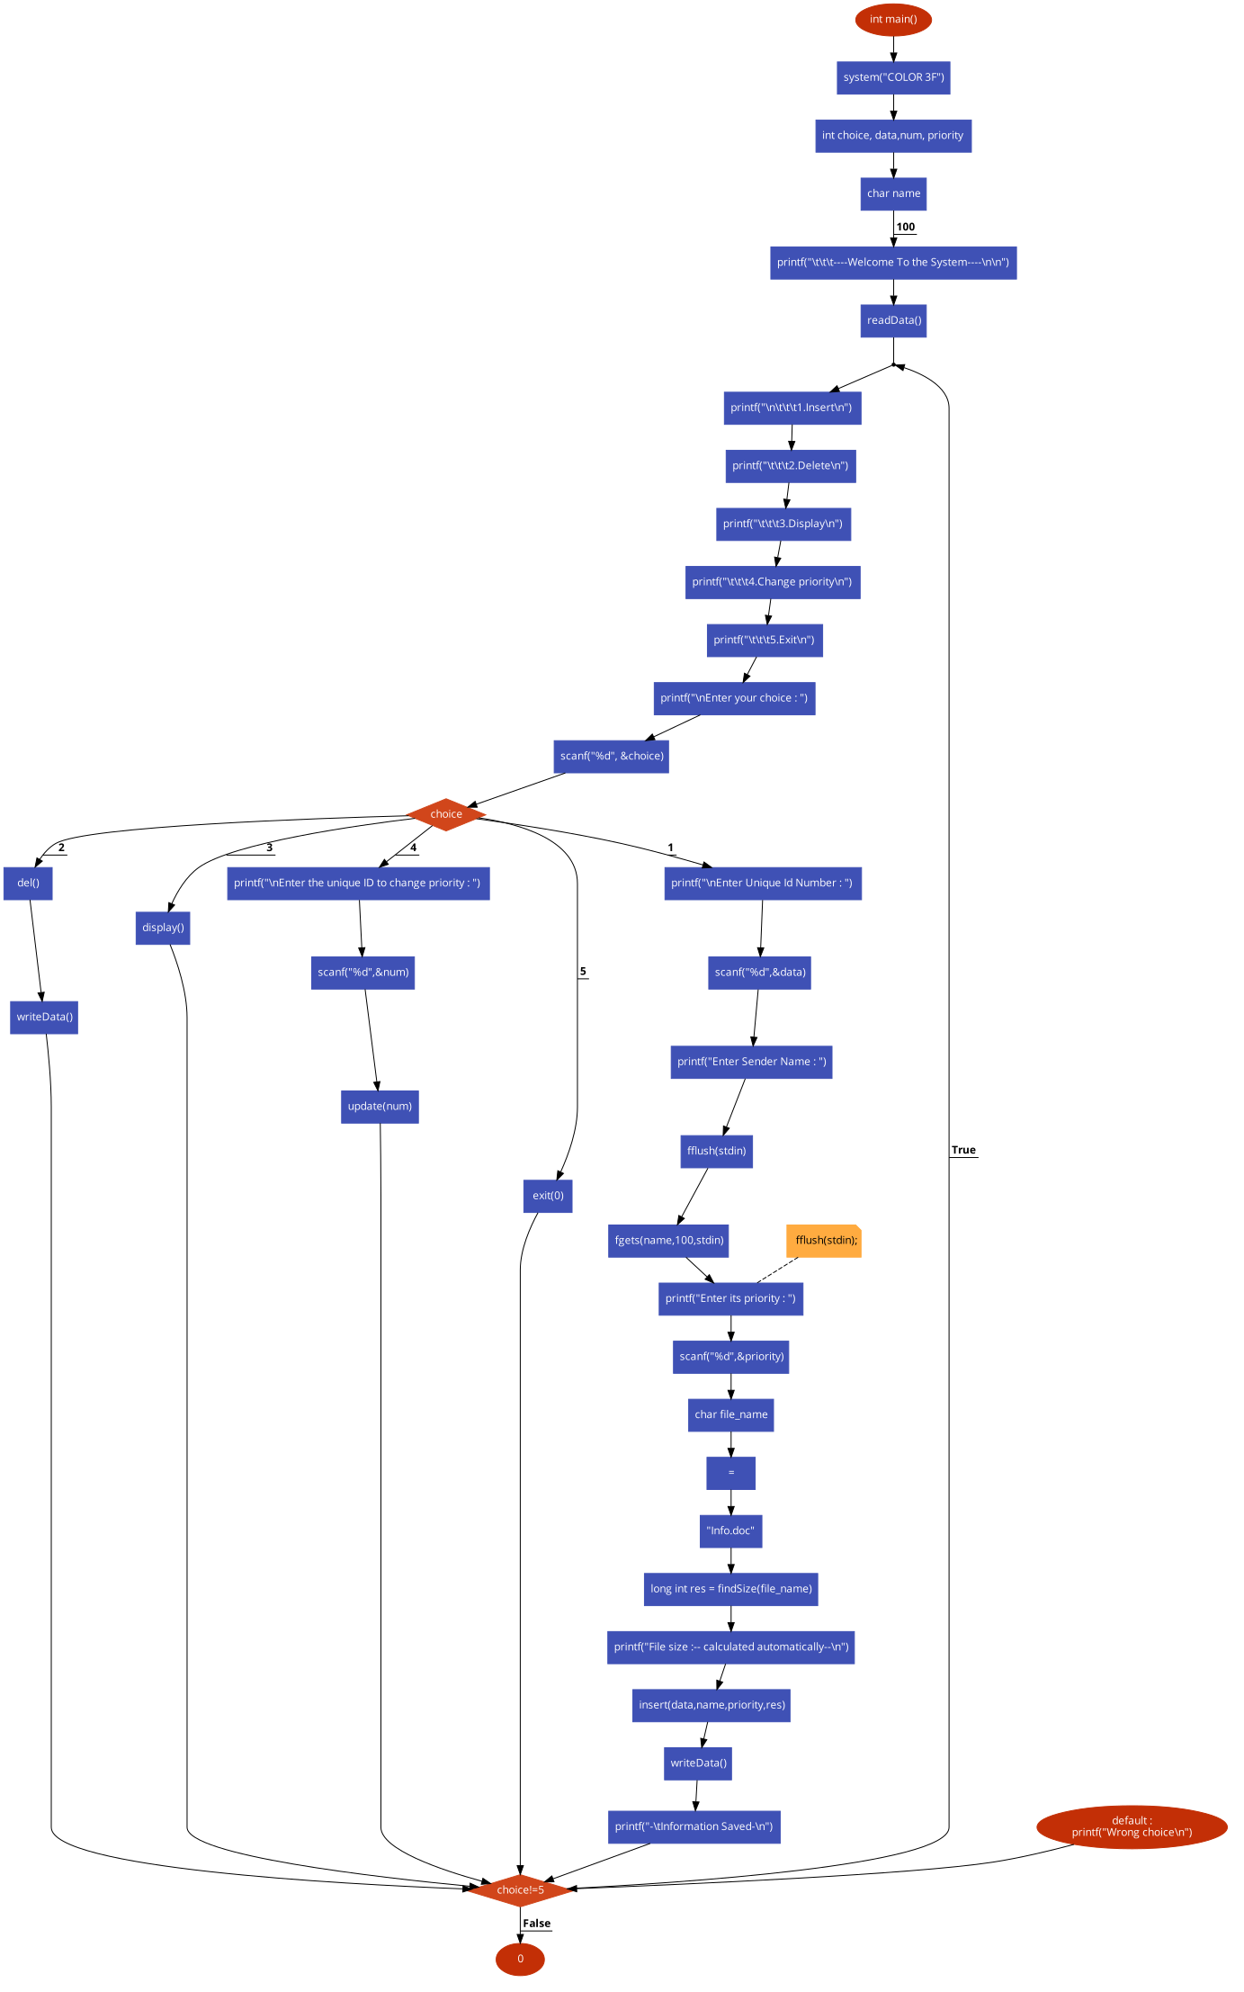 **Main Function**

**Core Data Structure**

1. We have made our module in C language.
2. Queue is used
3. Used Heap
4. Linked list implementation
5. File Handling

C language is easy to handle so we choose C Language. To store data in an organized and efficient manner we used Data Structure. Here we used Queue, heap and linked list. We also used file. Linked list is used to take each individual data from the client. To marge multiple data is hard in array but in linked list it is easy to handle. We used heap because it was easy to make a priority queue using minimum heap algorithm. To save time and store each information we used file and also to view the information and file size.

**Discussion**

This program can be used in many ways.

**Priority queue in scheduling the jobs in operating system:** Operating system allocates priority to the jobs the jobs are placed in the queue and the position of the jobs in the priority queue are determined their priority.

**Network Communication:** To manage limited bandwidth for transmission the priority queue is used.

Also in stock market, auction, hospital emergency queue, railway, airlines reservation priority queue can be used. As these reservations prefer fast come fast service and sometimes also quota system. So, people with the higher priority can be chosen and be served fast using this.

we can use SQL and PHP. This model can be easily converted into C++ and java. Besides in future many optimistic features can be added into the module.